# Battle of the Neighborhoods — Coffee Shop in NYC

IBM Coursera Capstone Project

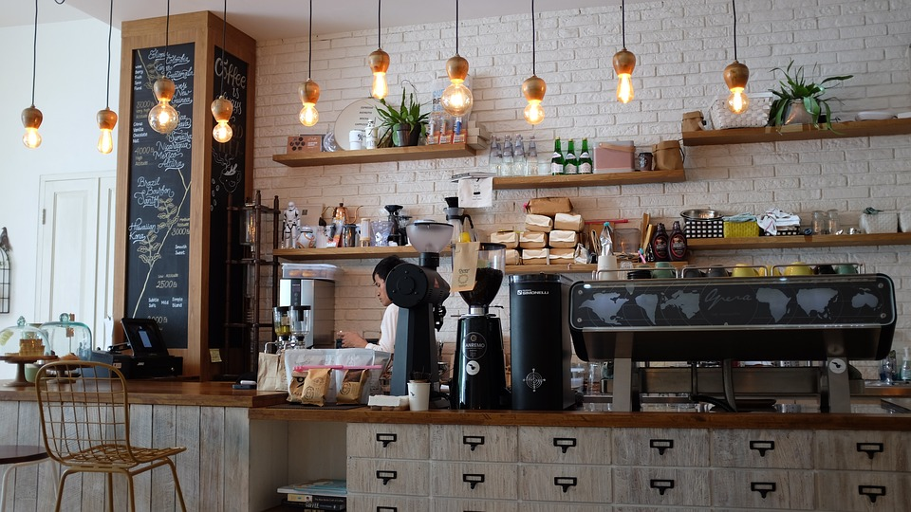

by Anna Kamneva

TAble of  
Contents

Introduction 1

Data 1

Methodology 1

Results 1

Discussion 1

Conclusion 1

Reference 1

# introduction

New York City is one of the most famous, romanticized and desired cities for living in the world due to its image portrayed in pop culture. Some of the worlds’ most popular content creators and influencers are located in the city for its stunning backgrounds and instagrammable dining and coffee locations. Combining that with the overall growing trend for coffee and small business coffee shops makes it an attractive investment to open a new coffee shop specifically in NYC where this coffee shop is likely to receive a lot of attention on social media to drive revenue.

According to Business Wire’s “Coffee and Tea Global Market Report, 2020-30: COVID-19 Impact and Recovery” report, the total coffee and tea market is predicted to grow from $142.1 billion in 2019 to $148.5 billion in 2020, an annual growth rate of 4.6 percent.

Based on the business type and for the sake of this capstone project, our simplified assumptions for the best location would be a high-density population area with a relatively low number of existing coffee shops. Existing competition might in reality be a good factor as a specific neighborhood could be famous for its coffee shops and would attract more customers. In this project, we will examine the landscape of the city on existing competition to identify the best location for investment.

## data

Data used to approach the above business case included:

* New York City neighborhoods’ and boroughs’ geographical locations (incl. latitude, longitude, and borders). Data Source: <https://cocl.us/new_york_dataset>
* Existing laundromats’ locations. Data Source: FourSquare API
* Population density of each borough. Data Source: http://www.demographia.com/dm-nyc.htm

## Method

After collecting data from <https://cocl.ed/new_york_dataset> I wrangled it into a data frame format as illustrated below.

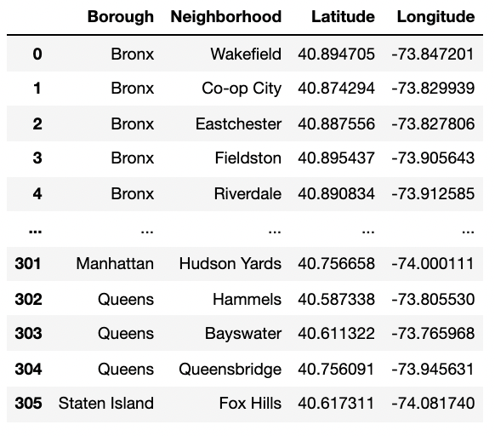

Using the density data I excluded boroughs that have a population density below average in NYC.

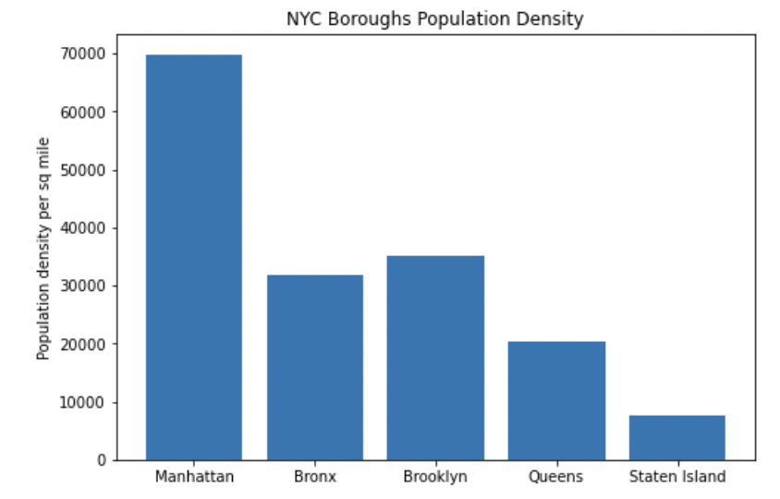

The remaining boroughs (Manhattan and Brooklyn) were then illustrated on the map.

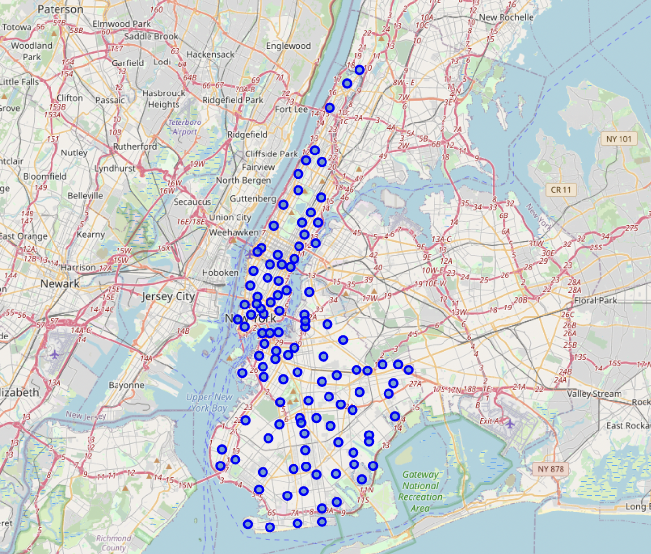

Finally, using FourSquare API I could locate all coffee shops within the above boroughs together with their rating statistics.

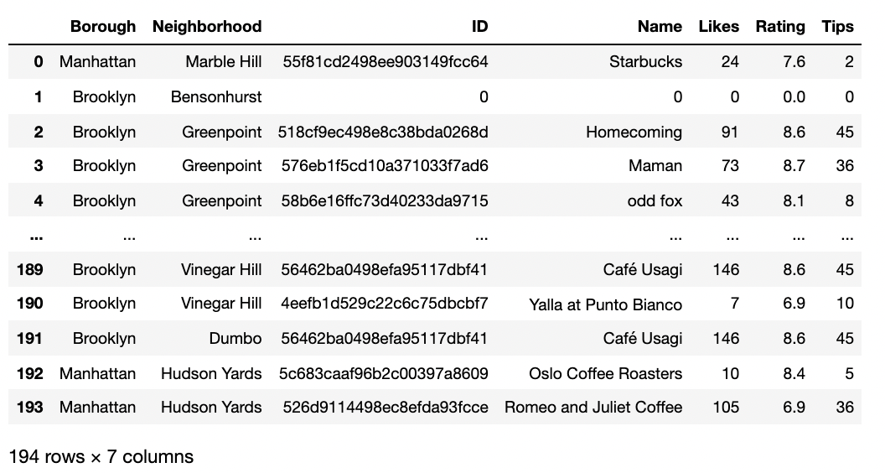

There is a total of 194 coffee shops in the resulted dataset. I then decided to focus on locations with the highest average coffee shop rating but a lower number of coffee shops. Below are the top 10 neighborhoods by their average rating combined with the number of coffee shops in the area for comparison.

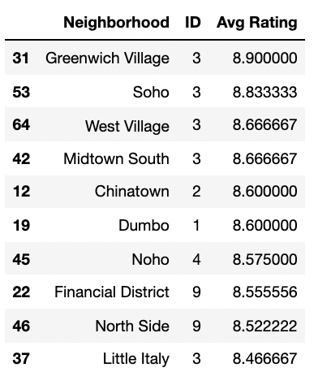

## results

All top 5 neighborhoods by the average rating have 3 or fewer coffee shops, which is a relatively healthy competition for our new coffee shop.

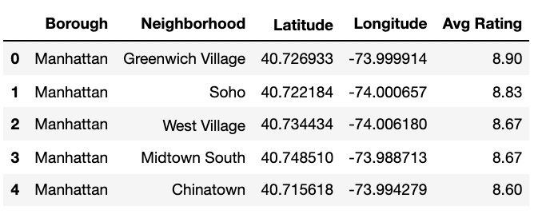

So, after deciding on choosing the location from these 5 neighborhoods, what’s left is to identify and visualize their location for assessment. The following is the dataset after merging it with the first dataset which includes latitude and longitude coordinates.

I could then visualize the neighborhoods on the NYC map to make final decisions.

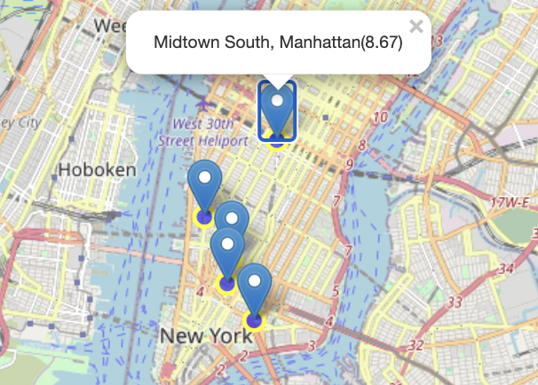

It is evident that other than Midtown South, they are in close proximity to each other. Therefore, to attract a larger volume of customers, I would recommend opening a coffee shop in either Green Village, Manhattan or Soho, Manhattan to be in close proximity to other highly rated neighborhoods.

## Discussion

Undoubtedly, this type of analysis is very simplistic and is based on my assumptions that the most optimal location of a coffee shop in NYC would be in a densely populated area with existing high rating coffee shops. New York City is a big city with a diverse population with different tastes, so it is highly likely that other approaches will also be optimal for a profitable coffee shop location identification, if not better. Furthermore, location is only a fraction of what defines a good coffee shop, coffee quality, menu offerings, interior, service are only a few very important factors.

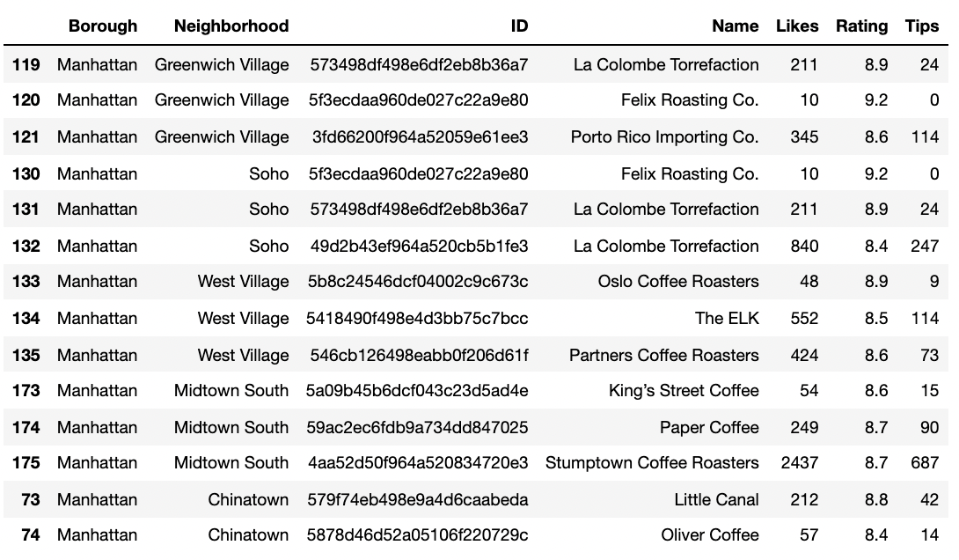

One of the other reasons I believe Soho and Greenwich could be a great location for a coffee shop is that both of those neighborhoods’ coffee shops are almost all chains and are the same between each other, with the exception of Porto Rico Importing Co. Having a completely different and non-chain coffee shop is a great potential for success. Therefore, it is recommended for a future coffee shop owner to work on the shop concept to make it unique among the existing ones in the two neighborhoods.

## Conclusion

With the popularity of coffee in recent years, coffee shops became attractive business all over the world. Even though the above analysis is very simplistic, it could be used for an initial study of the existing competitive landscape. One can further build on top of this analysis for a more thorough study or adjust it for another type of business or another city.

## References

* New York City dataset: <https://cocl.us/new_york_dataset>
* New York City (2000) Population Density data: <http://www.demographia.com/dm-nyc.htm>
* Coffee Shops locations and ratings: FourSquare API
* Coffee trends and background: <https://linchpinseo.com/trends-in-the-coffee-and-tea-industry/>
* Coffee and Tea Global Market Report, 2020-30: COVID-19 Impact and Recovery report: <https://www.businesswire.com/news/home/20200612005202/en/Global-Coffee-and-Tea-Market-Outlook-2020-2030-COVID-19-Impact-and-Recovery-Assessment---ResearchAndMarkets.com>